[](https://www.iiuc.ac.bd/)

**FINAL Term Project**

**Project Name:**

**Employee (Allowance) Management System**

**Submission date- 12 October , 2021**

**Course Title- Software Development 1**

**Course Code: CSE-2340**

Submited to-

**Mr. Mohammad Mahadi Hassan**

***Assistant Professor, CSE, IIUC***

***Cell: 01957719040*, mahadi.cse@yahoo.com**

Section: ***3AM* ,** Semester**: *3rd***

**Department of CSE (***Computer Science and Engineering***), IIUC**

Submitted by-

**MD. SOROWAR MAHABUB RABBY**

**Matric ID: *C201032***

**Cell:** *01834756433, 01521564157*

[*c201032@ugrad.iiuc.ac.bd*](mailto:c201032@ugrad.iiuc.ac.bd)

Submitted by-

**MOSTAFA SHAHRIAR ASIF**

**Matric ID: *C201014***

**Cell:** *01856685830*

[*c201014@ugrad.iiuc.ac.bd*](mailto:c201014@ugrad.iiuc.ac.bd)

**Employee (Allowance) Management System** is a software-based application developed in Java programming language. The project aims at serving the department of employee of a company/ varsity by computerizing the salary, allowance system. It mainly focuses on the calculation of allowance during the specified time/ occasion and the salary to be paid to employee/ offices. This computerized system will make the overall Employee Management system easy, accessible, comfortable and effective for companies.

Here, I have briefly described this project with its features and by comparing it to the conventional system of employee management.

**Objective of Java Payroll Project-** **Employee (Allowance) Management System:**

1. The main objective of the Java Project on Payroll Management System is to manage the details of Employees, Payments, Salary.
2. It also manages all information about the Employee, Payroll and Salary Slips.
3. The project is totally built at administrator end of things.
4. Only the administrator is guaranteed the access.
5. The purpose of the project is to build an application that reduces the manual work and it can be used as a school project.
6. Functionalists provided by the Java Project on **Employee (Allowance) Management System**.

**Features:**

1. Provides search facility such as searching for Employees, Salaries and reports.
2. Tracks all salaries and employee payments.
3. Stores all information about employees to a secure Sql database.
4. Generates reports using.
5. Manages all information of Employees.
6. Simple GUI.
7. Editing, adding, deleting and updating records couldn't be easier.
8. Manages all information of employees salaries.
9. Manages all information of employee payslips.
10. Manages all information of employee allowance.
11. Manages all information of employee Report generation.
12. It generates reports of all employees, Payments and salary slips.
13. You can easily export PDF for employee , Payroll, Payslips , Allowance and deduction records.
14. Save PDF to any location.

**Abstract**

This report includes a development presentation of an information system for managing the staff data within a small company or organization. The system as such as it has been developed is called Employee Management System. It consists of functionally related GUI (application program) and database. The choice of the programming tools is individual and particular.

**Keywords** Information system, Database system, DBMS, parent table, child table, table fields, primary key, foreign key, relationship, sql queries, objects, classes, controls.

**Screenshots:**

**1**

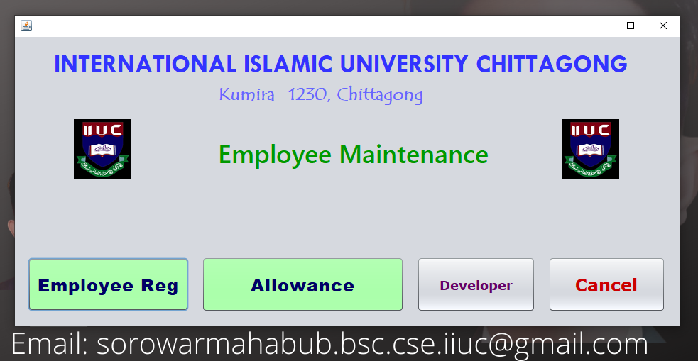

**2**

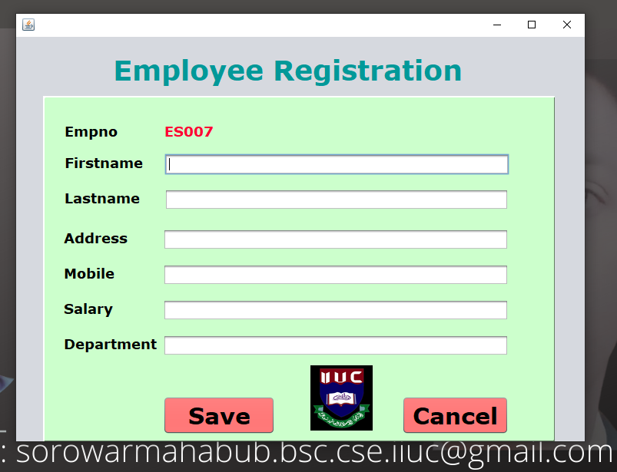

**3**

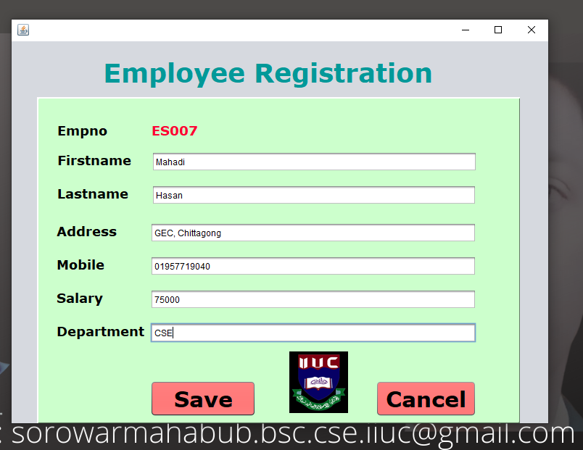

**4**

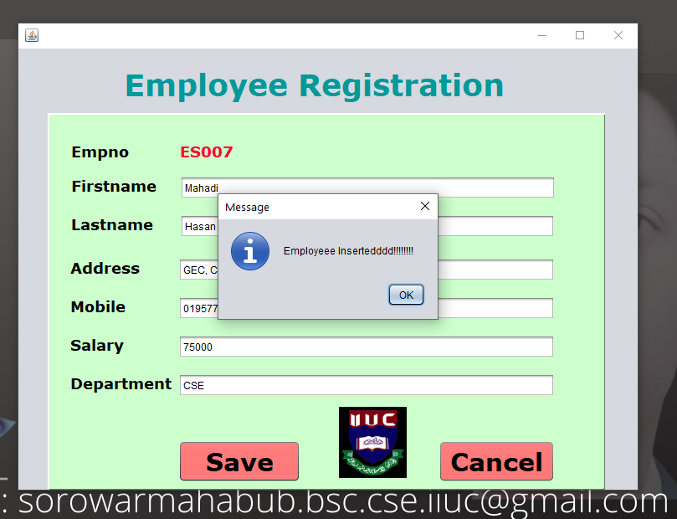

**5**

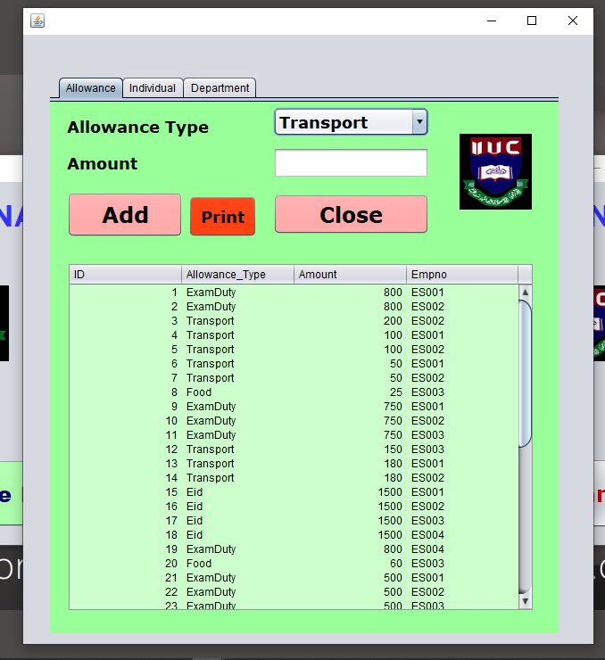

**6**

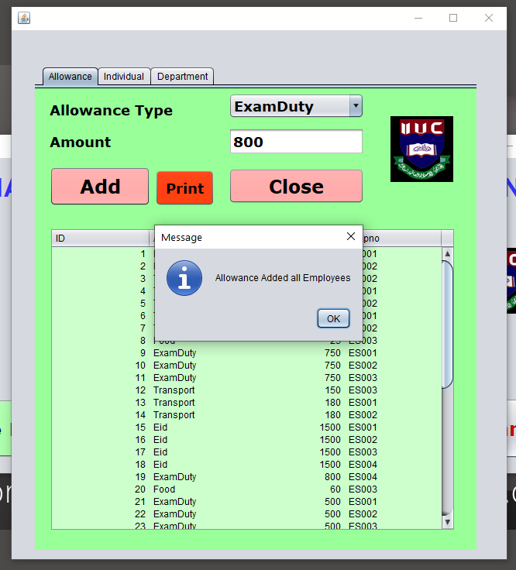

**7**

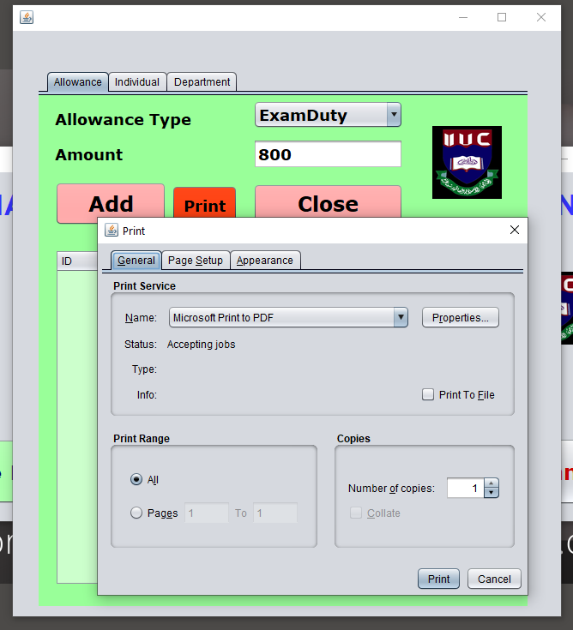

**8**

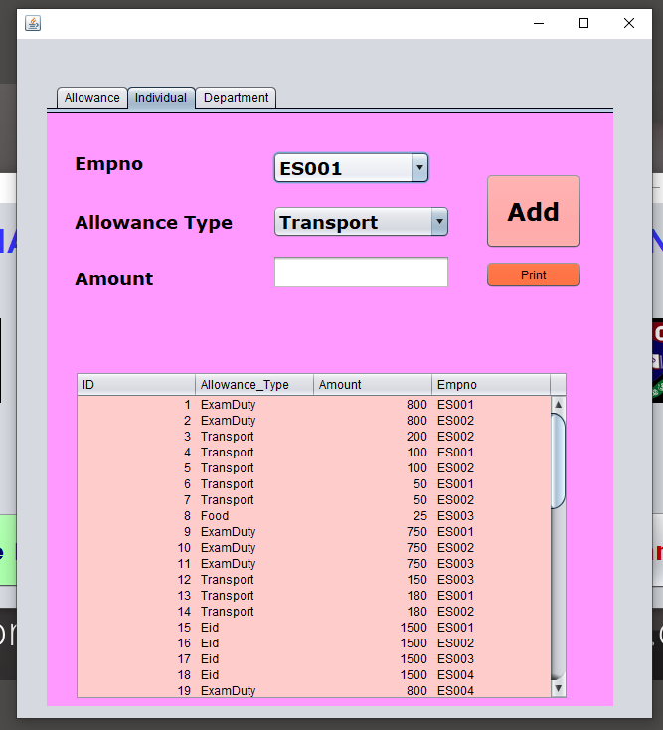

**9**

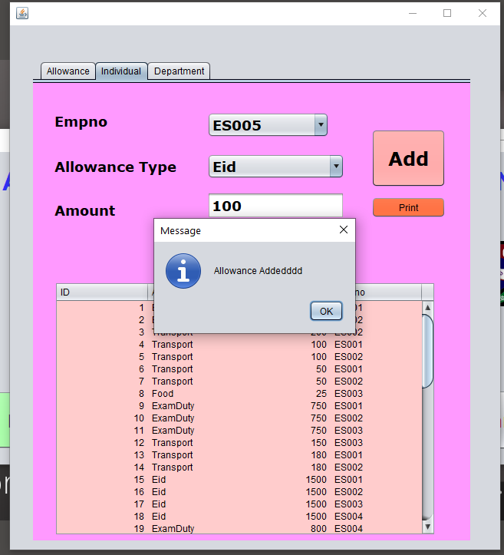

**10**

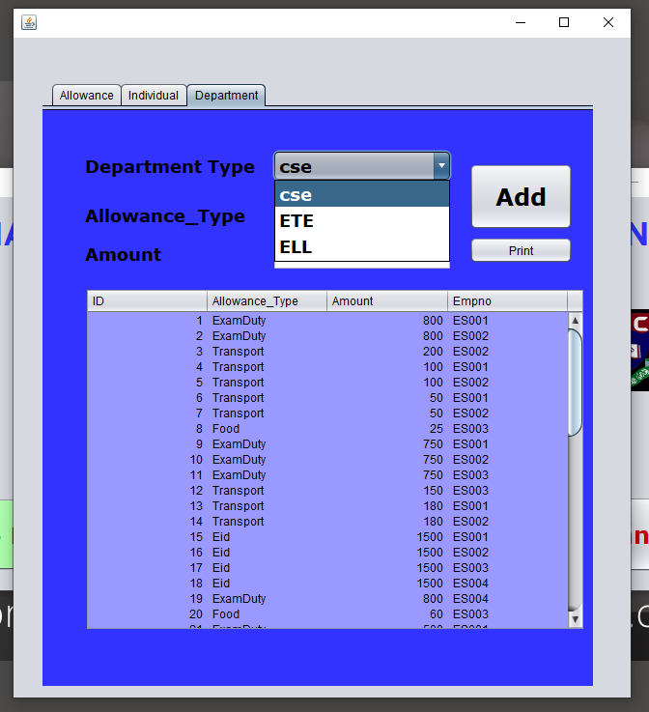

**11**

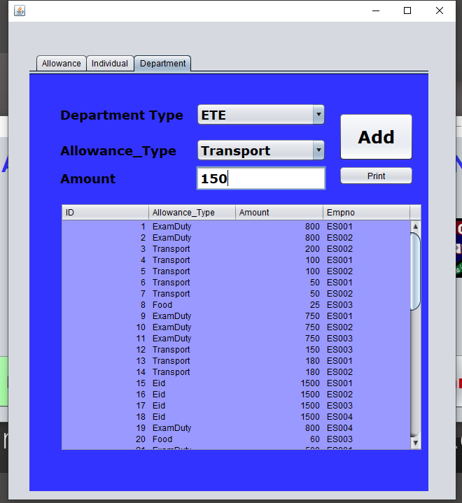

**12**

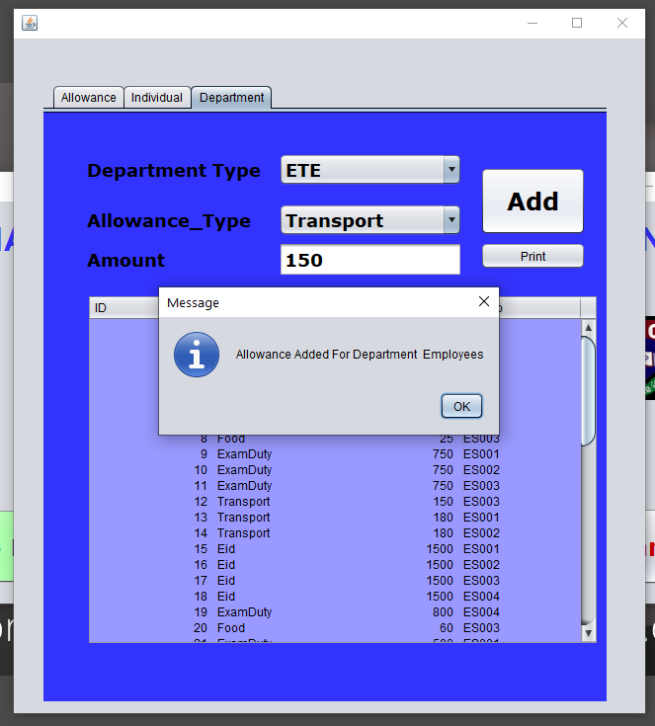

**13**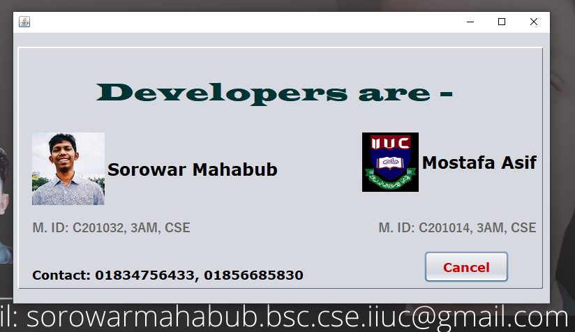

**14**

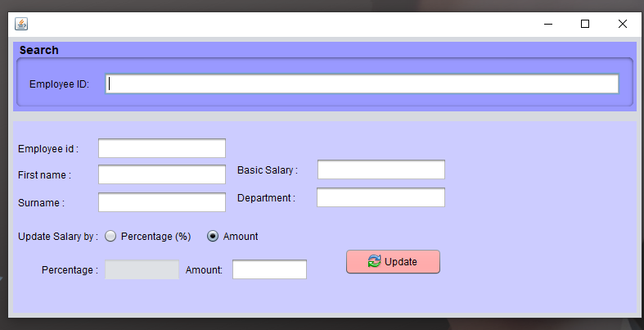

**15**

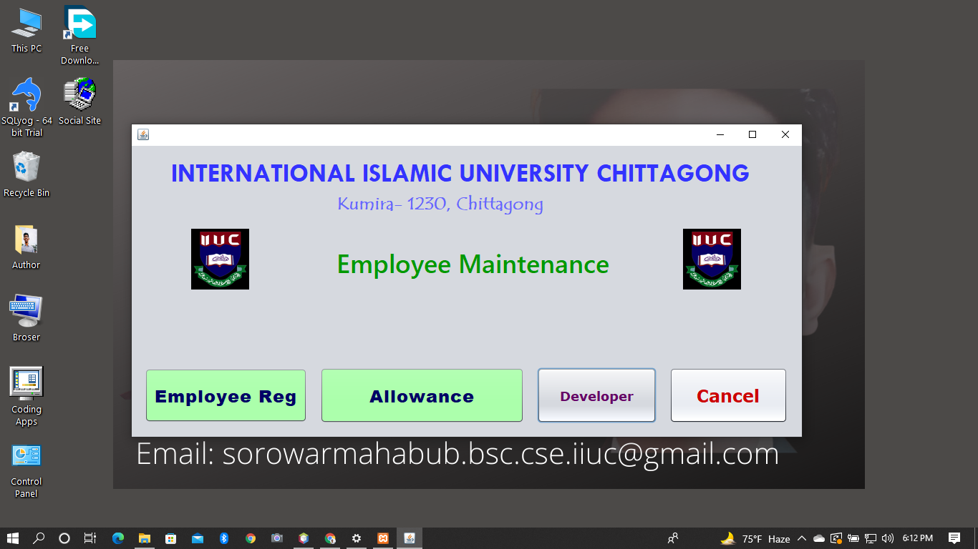

**Conclusion:**

Employee management that is effective understands the work, the type of person who would be a good fit for the job and the organization, empowers the employee to accomplish the job, and treats employees with respect. However, you cannot be effective unless you are well-organized. As a result, the first step is to organize your workspace.

So that completes our discussion for Employee Management System Project Proposal, Abstract, Documentation PDF and PPT. You may check the complete illustration of Diagrams, Source Codes and Documentation by clicking the titles of each explanation.

**Submitted by-**

**MD. SOROWAR MAHABUB RABBY**

Matric ID: **C201032**, Section: 3**AM**

Department of CSE (Computer Science and Engineering)

and

**MOSTAFA SHAHRIAR ASIF**

Matric ID: **C201014**, Section: 3**AM**

Department of CSE (Computer Science and Engineering)